CSA05-DATABASE MANAGEMENT SYSTEMS
LAB OBSERVATION
EXPERIMENT:06
AIM:
To view the records from the tables using SELECT commands with BETWEEN, IN, Aggregate
functions.
QUESTION:
- List the type of the courses “Statistics” and “Programming”
SQL QUERIES:
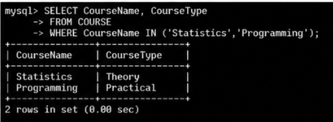
- The instructor wants to know the CourseNos whose scores are in the range 50 to 80
SQL QUERIES:

- Find the average mark of “C002”.
SQL QUERIES:
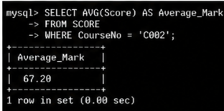

- List the maximum, minimum mark for “C002”
SQL QUERIES:
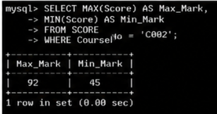

- List the maximum, minimum, average mark for each course
SQL QUERIES:
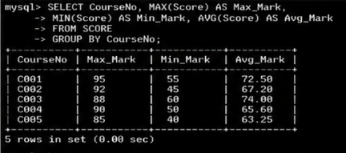

- List the name of the courses and average mark of each course.
SQL QUERIES:
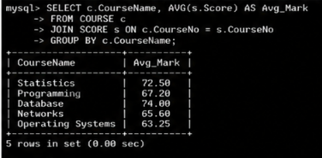
- Calculate the sum of all the scores.
SQL QUERIES:
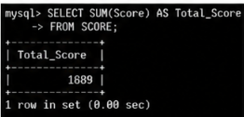
- How many students are registered for each course? Display the course description and the number of students registered in each course.
SQL QUERIES:
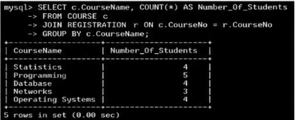
9. How many courses did each student register for?
SQL QUERIES:
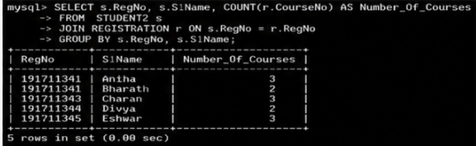

RESULT:
The records from the tables are displayed using SELECT commands with WHERE Clause and Pattern matching.

